How to View Your Account Activity

In your WaveNet account, click on Finances. You will now see the ACCOUNT ACTIVITY just below the Account Summary section.
Use the calendar box to view the activity between certain dates or click on the drop down arrow to view by term. If viewing by term, you may want to change the FROM date to 01/01/1901 so that it will show all transactions for that term.

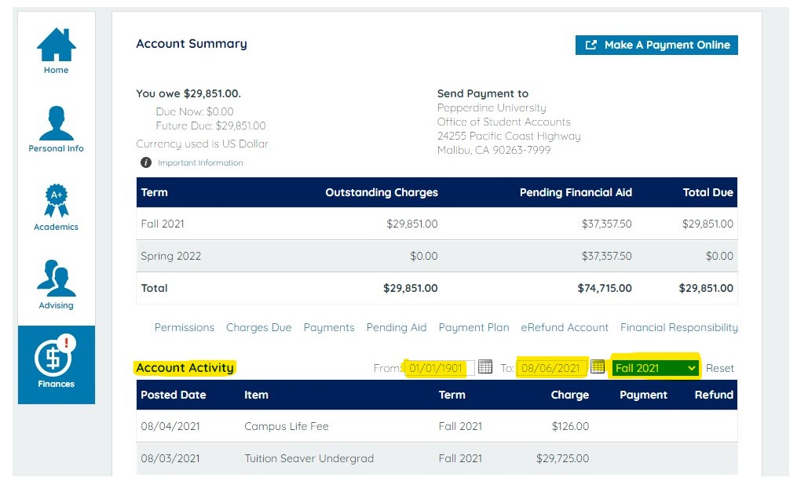

The Account Activity section will provide you with the detail on each transaction entered on the account. You will notice there are three types of entries: CHARGE, PAYMENT, and REFUND.
Each line will give the description of the item and then the amount will show in the appropriate column: CHARGE will include all tuition and fees, PAYMENTS will include all payments and financial aid, and REFUNDS are refunds issued from the account.

If a transaction is reversed, there will be a (-) sign in front of the number to indicate that amount was deducted for that item.
Example: student drops units so the tuition is reduced-that would show in the charge column as the amount deducted with a (-) sign in front of it.
This could also occur if a financial aid item was reduced. The amount reduced would show in the Payment column but with a (-) sign in front of the amount. In summary, any amount with a (-) sign in front of it is a reduction of that amount from the original amount charged.

Example below: Student’s Federal Subsidized Loan 1 ($1517.00) was canceled. You will see there are four transactions for this loan. One of $1517.00 which is the original awarded amount. Then three transactions with (-) signs in front of the dollar amount. If you total up these three it equals $1517.00. The loan amount is now $0.

